**GOVERNMENT DEGREE COLLEGE, GUMMALAKSHMIPURAM**

**DEPARTMENT OF HISTORY 2023-24**

**Name of the Event: Dr. BR Ambedkar Birth Anniversary**

**Guest of Honor : D. Ramaiah (Vice- Principal)**

**Date                      : 12-04-2024**

**Department              : History**

**Lecturers Attended: 08**

**Students Attended: 30**

**Dr. Br Ambedkar Birth Anniversary 2024, the day celebrated in the college in April -12-2024. The guest of honor was D. Ramaiah Garu, Vice- principal of the college , delivered a message , Ambedkar life history and achievement, All Staff  Members and Students Participated in this Programme.**

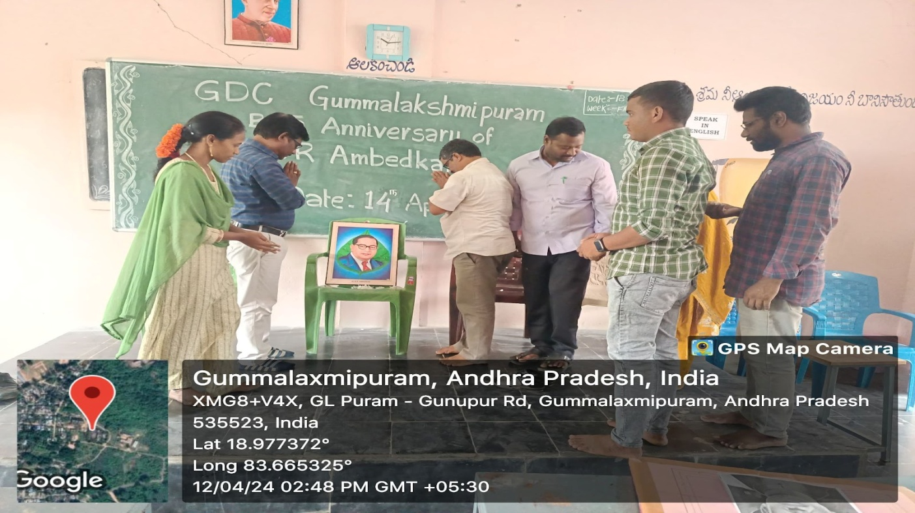

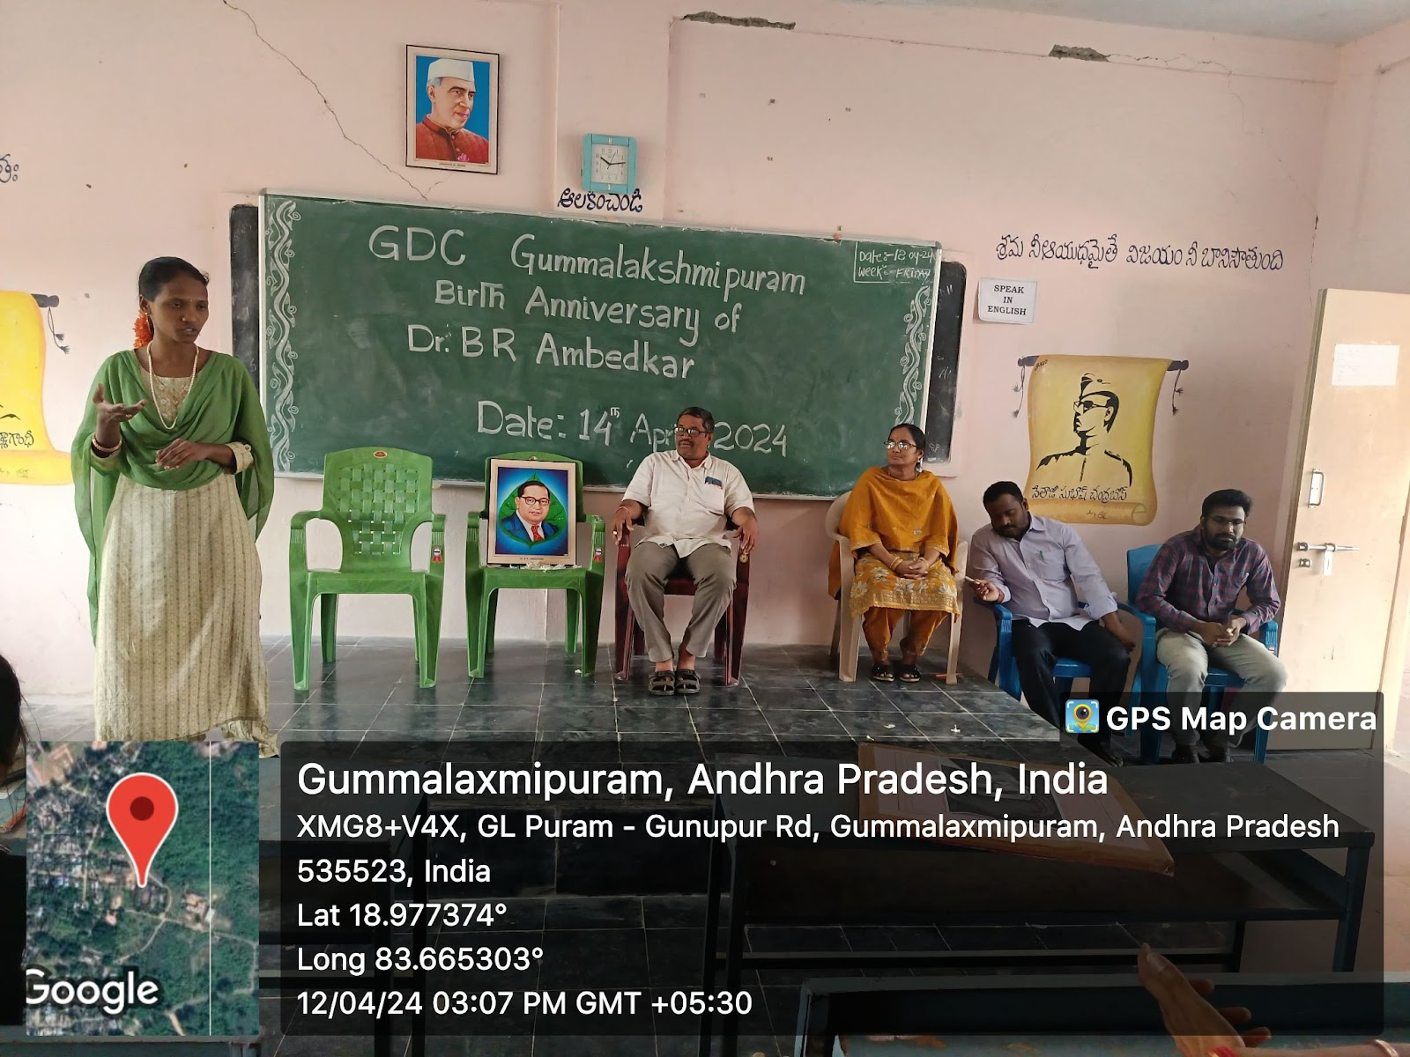

**Speech Given by Lecturer in History A. Srivani**

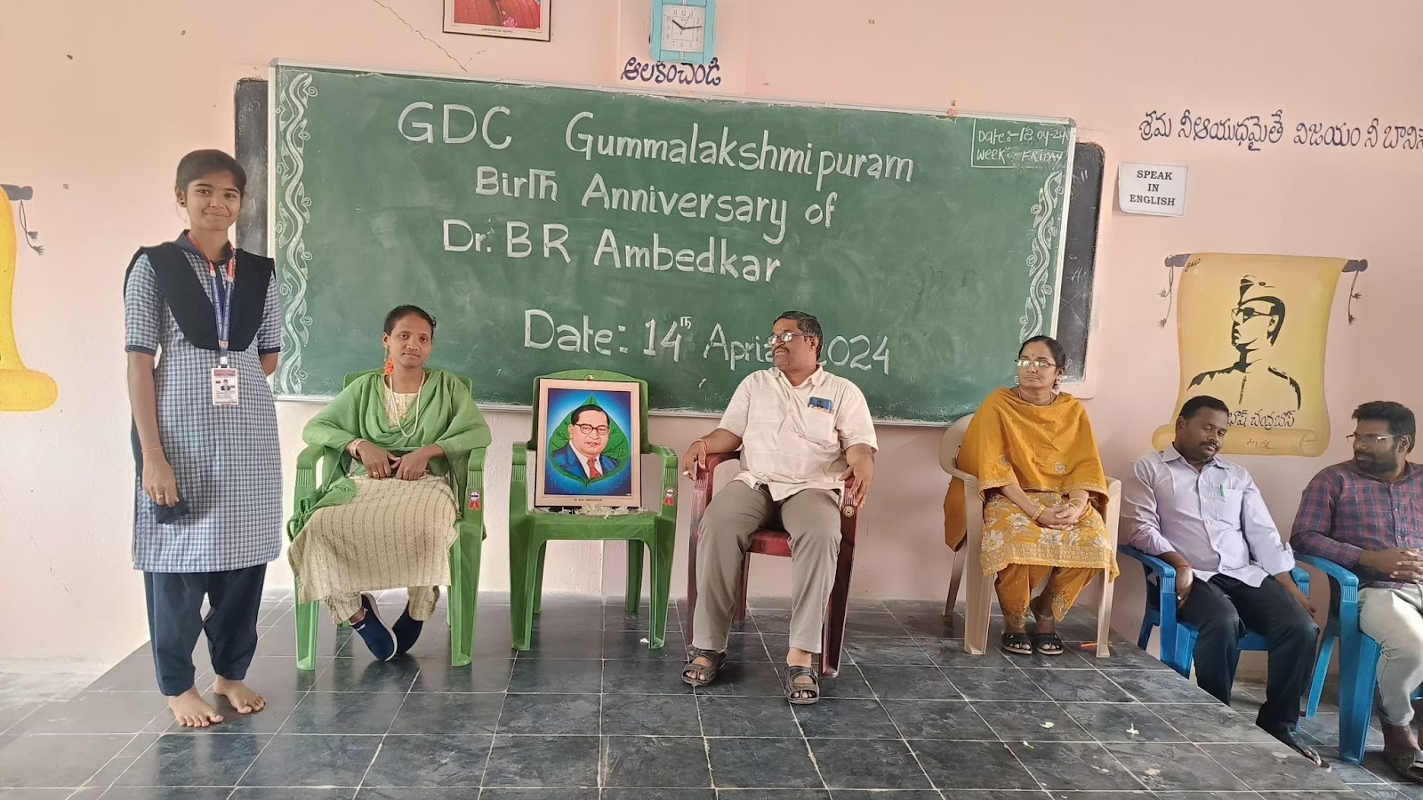

**Speech Given By Student**

**Conclusion: As we conclude the celebration of Dr. B.R. Ambedkar’s birth anniversary, let us reflect on his immense contributions to India and his vision for an equal and just society. He was not only the chief architect of the Indian Constitution but also a tireless advocate for social justice, equality, and human rights. His life teaches us the importance of education, perseverance, and standing up against discrimination. Let us honor his legacy by continuing to fight for the principles he stood for liberty, equality, and fraternity. True respect for Dr. Ambedkar lies in upholding these valuesin our daily lives and working towards a society where every individual, regardless of caste or background, has equal opportunities to grow and succeed.**